**Assignment -4**

**Docker and kubernetes**

|  |  |
| --- | --- |
| Assignment Date | 28 october 2022 |
| Student Name | Ms.sneka.L |
| Student Roll Number | 612419104021 |
| Maximum Marks | 2 Marks |

**Question-1: pull an image from docker hub and run it in docker playground.**

**1)pull an image form docker hub**

|  |  |
| --- | --- |
|  |  |

**2)runt it in docker playground**

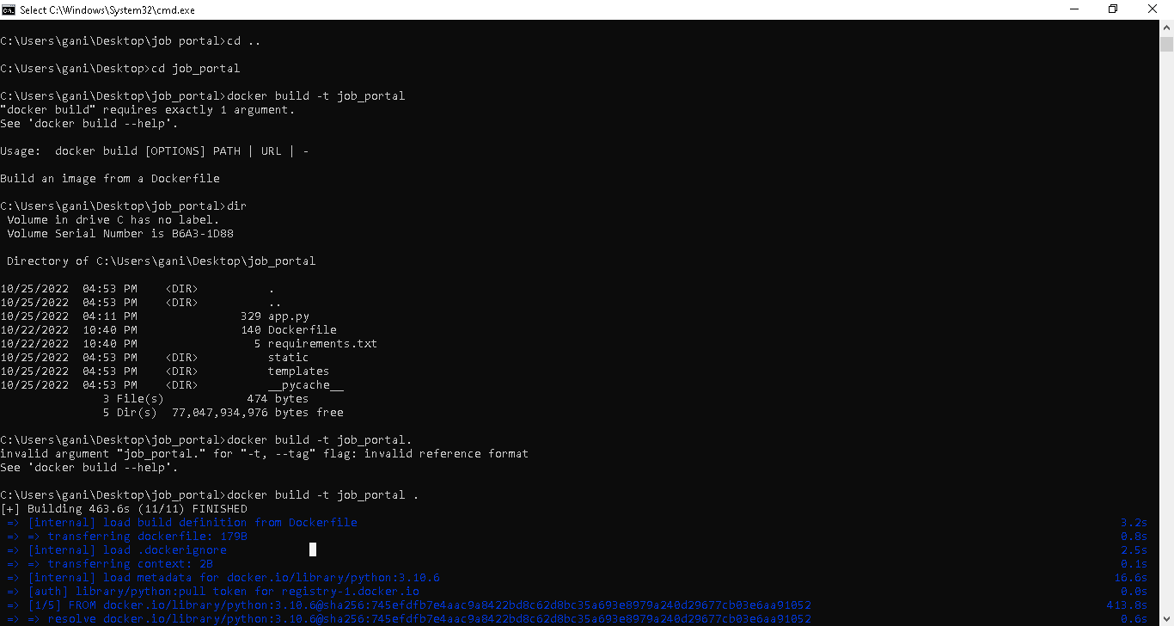

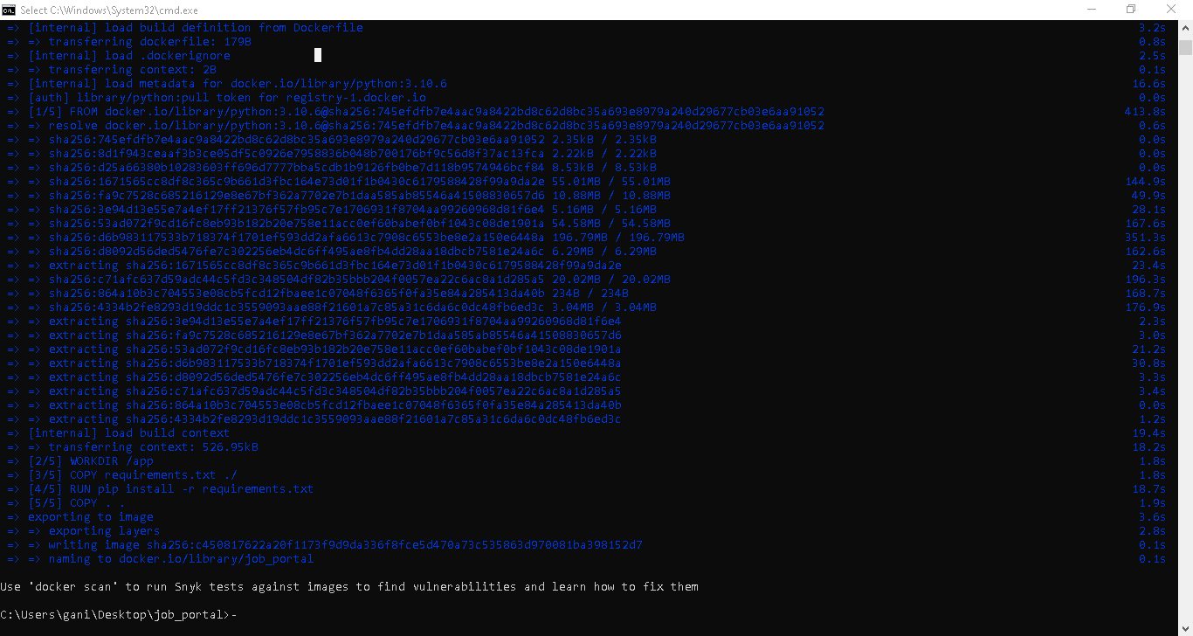

**Question-2: Create a docker file for the jobportal application and deploy it in docker application.**

**1)Creating a docker file for the jobportal application**

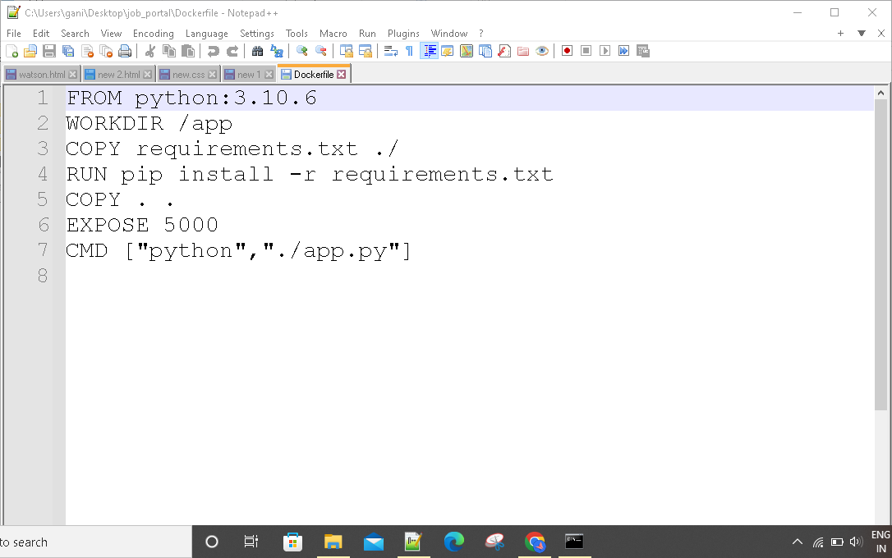

**2)deploy in in dokcer application**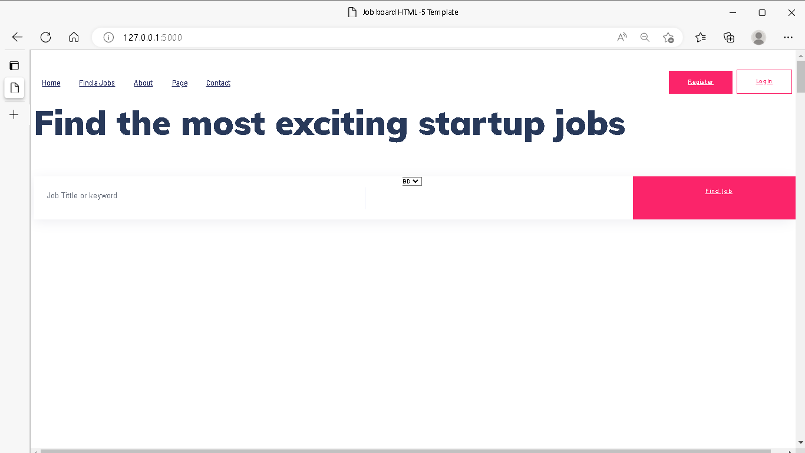

**Question-3:Create aIbm container registry and deploy helloworld app or jobportalapp**

**1)create a ibm container registry**

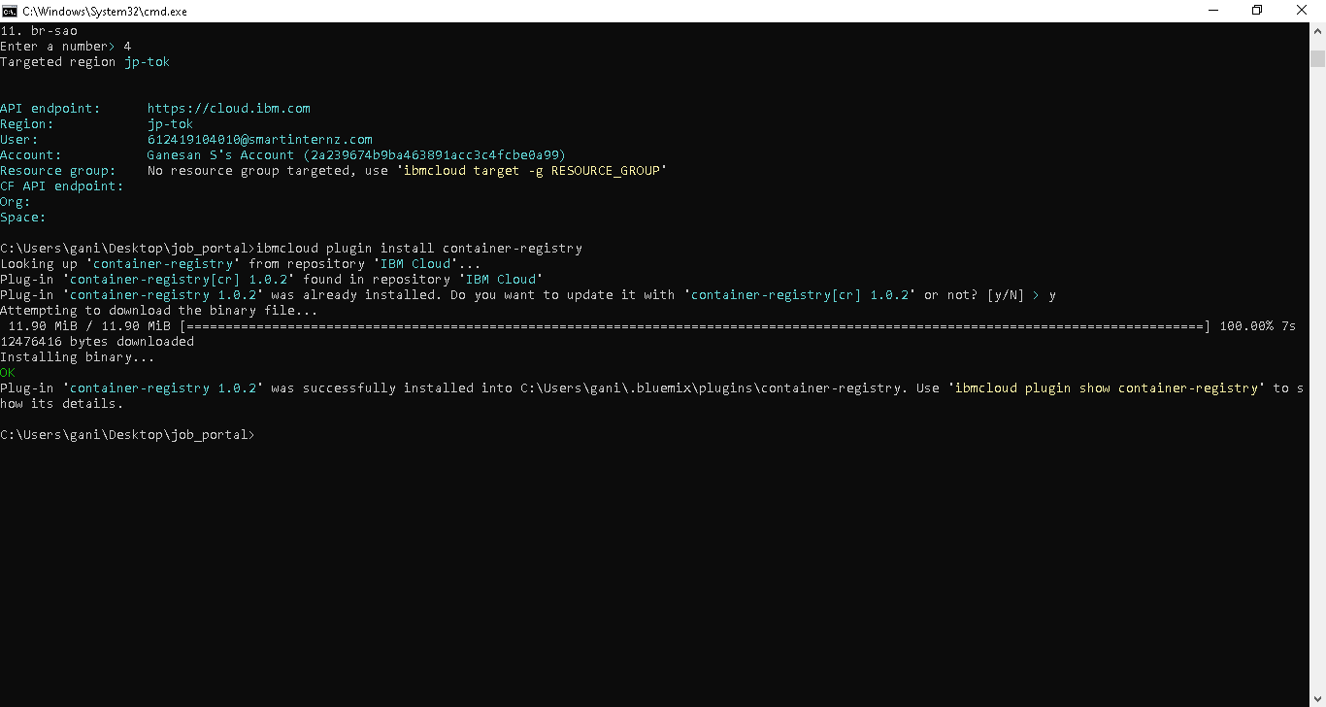

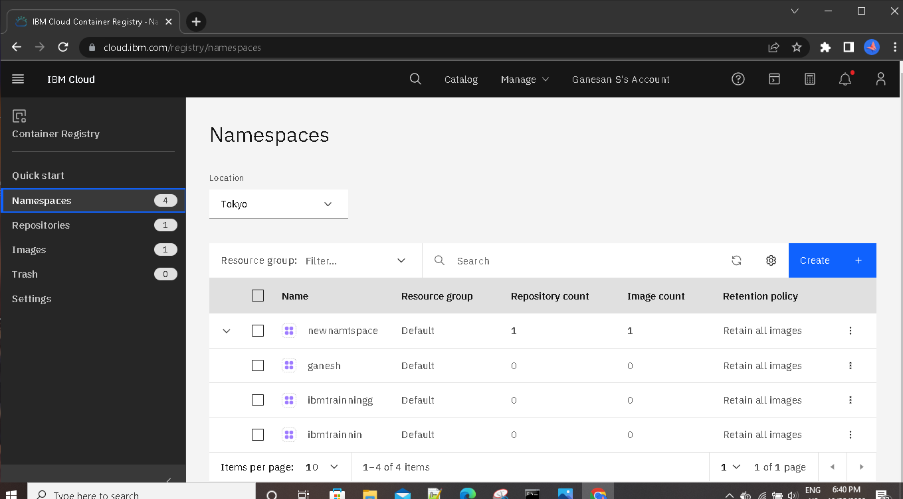

**2)deployhelloworld or jobportal**

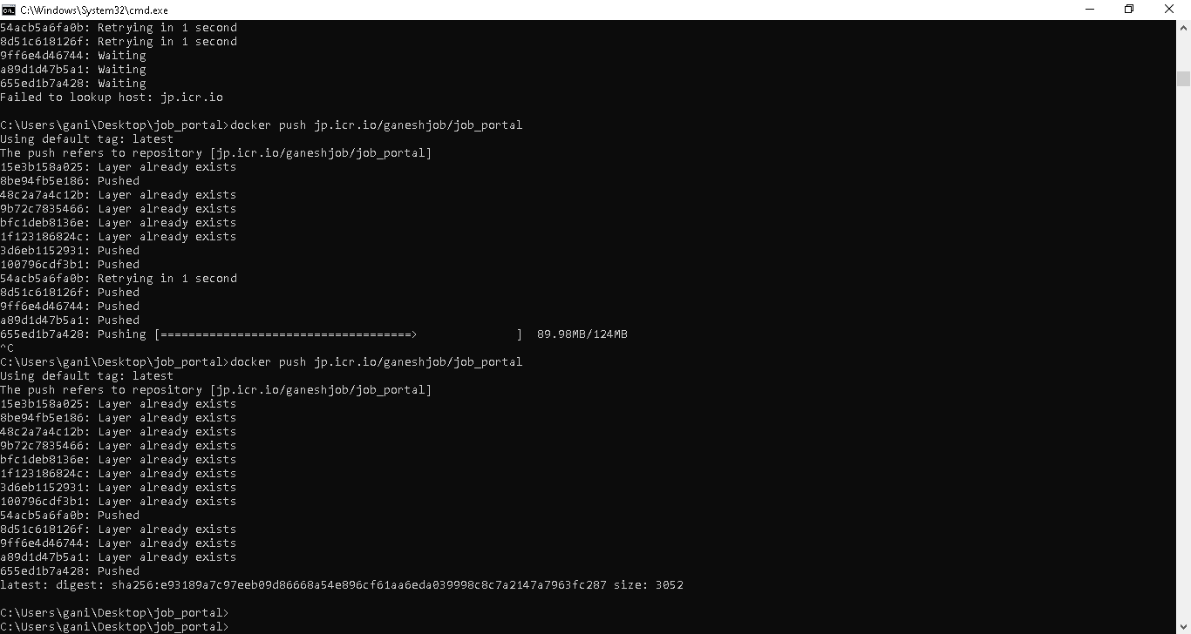

**Question-4: Create a kubernetes cluster in ibm cloud**

